**TTP Meteor Ltd.**

**INDUSTRIAL PLACEMENT FINAL REPORT**

**A universal test procedure including hardware into regression test**

**HAO DING**

# 1. Executive Summary

TTP Meteor Ltd is part of the Technology Partnership Group, a technology development and innovation centre, located in the Melbourne Science Park near Cambridge. The Technology Partnership was created 25 years ago and now the enterprise has grown and evolved into TTP Group [1], where a range of technical research and businesses take place. TTP Group provides a broad range of products and services in various market sectors, covering medical devices, aerospace and defence, communications, digital printing, etc. New ventures are placed under the umbrella of TTP Group and TTP Meteor Ltd is one of them.

TTP Meteor is specialised in providing powerful and flexible driver solutions for industrial printheads. Today’s industrial-used printheads are sophisticated devices, with high requirements on precision, quality, print speed and scale, which have direct influence on the quality and efficiency of manufacturing process. Therefore, different printhead electronics and software must be optimised to achieve the best performance. TTP Meteor provides a flexible and powerful architecture, associating various printheads to the Meteor PrintEngine Software, which can be re-configured simply to meet the changing and evolving environment in printing market, including ceramics, textiles, wide format, labelling and digital press.

My project in TTP Meteor involves developing a universal testing architecture, which includes hardware components into the regression test procedure. The fast-changing customer demand has led to the frequent upgrades in Meteor solutions while modifications in existing Meteor architecture may bring unforeseen outcomes to some specific types of printheads. By pseudo printing specific test patterns, collecting and analysing necessary signals from hardware, quick tests can be performed to determine whether the system is fully-functional. The universal test has the potential to be more accurate and convenient than test with actual printing, bringing higher working efficiency into company operation.

Apart from the main project as mentioned above, I was also allocated tasks in various other projects. The extra technical projects include developing testboards, which performs quick examination on manufacture errors before mass production. On the business side, I participated in providing customer support to those from non-English speaking countries, realising the direct communication between the engineers from both sides.

My placement project has been closely related to my college course content and requires me to apply and develop my knowledge in practical situations. In addition to that, I had the opportunity to broaden my skill set in PCB design, FPGA development and Windows application development. Integral to every successful business is its business strategy. TTP is no stranger to impressive business strategies, where new markets are explored which contributes to the independency of TTP Meteor. Having been part of the company for 6 months, it has given me deep insight into company management as well as business operation.

**Contents**

1. Executive Summary 2

2. Company Overview 4

3. Project Description 5

3.1 Project Background 6

3.2 Project Design Procedure 9

3.3 Technical Details 11

3.3.1 Adaptor board design 12

3.3.2 FPGA design 15

3.3.3 User Interface Development 16

3.3.4 Project Planning 20

3.4 Additional Work 21

4. Project Refection 21

4.1 Challenges 22

4.2 Personal and Professional lessons 23

4.3 Future work 24

4.4 Relevance to degree course 24

5. Conclusion 25

Reference 26

# 2. Company Overview

TTP Group is a world-leading technology and development company, focusing on meeting needs of companies through the use of advanced technology and innovations. It is located in a Science Part near Cambridge. The main industry TTP Group has a hand in is technical consulting, providing ideas and designing solutions to clients. It has played a pioneering role in a broad range of areas including drug discovery, pharmaceutical automation, laboratory instrumentation, digital printing, wireless communications and consumer products.

[2]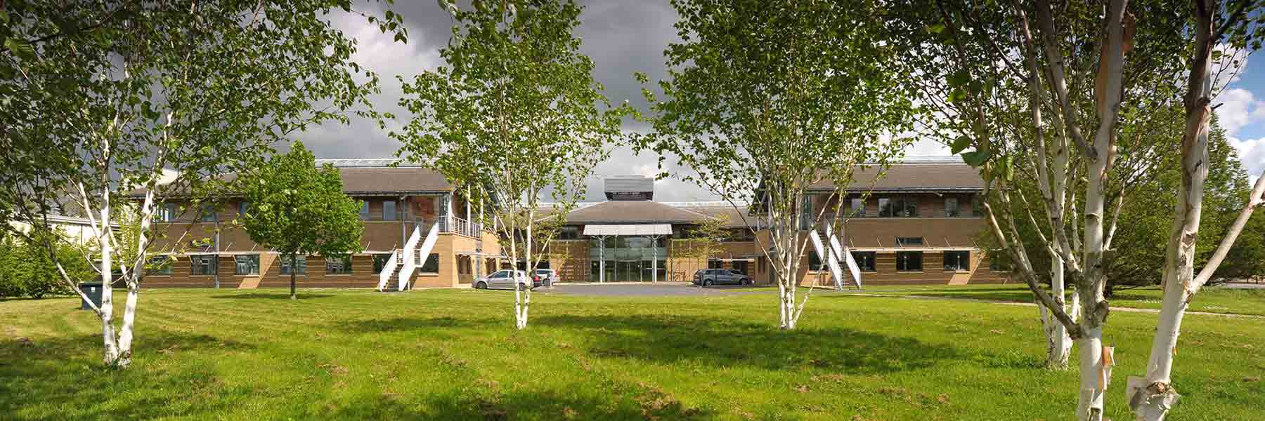

Twenty-five years ago, the Technology Partnership was established, which quickly expanded and reorganised under the new parent, TTP Group plc. As the business has grown, new companies have been created and flourished. Now TTP Group has more than three hundreds technical consultants and scientists, working in several independent enterprises within the group, such as TTP Labtech, TTP Venture Fund, etc.

TTP Meteor, which is closely involved in digital printing for decades, was established within TTP and has just officially become an independent company this year. TTP Meteor is not only limited in consulting business, but also including hardware production and customer support into the business. Now it has fourteen engineers and consultants, and a number of salesmen based in Europe, Asian and America.

TTP Meteor manages to stay extremely competitive due to its high performance solutions. Compare to common commercial-used printers, industrial used printers are far more complicated and demanding in terms of printing speed, precision and scale, which has direct impact on the productivity and quality of manufactures. In recent years, new technology and applications keep emerging, leading to broad and differentiated markets in printing industry. This incubates the idea of introducing a universal solution to complicated and diversified demand in industrial printing market. This idea eventually contributes to the birth of Meteor Group and becomes a unique selling point which brings the company large and steady annual revenue growth in the many consecutive years.

I joined TTP Meteor’s Research and Development, responsible for the operation of the universal testing project. My project progress was reported and discussed in weekly meeting within research and development team. In addition, In an effort to have company employees fully aware of the company’s ongoing state, TTP Meteor organizes monthly company business meetings, where monthly revenue reports, customer demand and human resource topics are part of the agenda.

During the six-month internship in this company, I received tremendous supports from my colleagues. With many years of experience in printing industry, they are far-sighted, knowing the potential steps, time allocation and possible difficulties as my project progresses. Communicating with them and following the suggestions from them prevented me from wasting time on redundant work. Being a member of this company has taught me a lot, not only the technical skills needed to be a good engineer, but also the ability to fit into a different environment, working and living with people specialised in different areas, at different levels in the company.

# 3. Project Description

My project during this placement is to develop a procedure which inspects and analyses hardware operations, including hardware components into the regression test. Regression test is defined as a type of test aiming to uncover bug after system change, such as software enhancement [3]. Before explaining any details, an overview of the typical ‘Meteor Architecture’, will be helpful in acknowledging the aim and working principles of this project.

## 3.1 Project Background

TTP Meteor has its origin in consulting industry, which has reputation for fierce competition and changeable environment. To satisfy the fast-changing demand from customers, Meteor developed its own architecture, providing a highly flexible and adaptive solution for printhead driver systems. By using the Meteor Architecture, users are able to switch their printhead options among the twenty supported printheads, with low cost, to select the most suitable one to maximise their benefit.

**User Input**

**Windows Application**

**Print Controller Card**

**Head Driver Card**

**Head Driver Card**

**… …**

**Print Head**

**Print Head**

**… …**

Windows Application:

User interface and command control

Head Driver Card (HDC):

Driver unit for different printheads

**Figure 1.** The Meteor Hardware Architecture (the blue area).

Print Controller Card (PCC):

Central hardware control unit

Figure 1 illustrates the basic Meteor Hardware Architecture, controlling and coordinating multiple printheads. The Meteor Architecture consists of three major components: a software application, a print controller card (PCC) and a head driver card (HDC). Figure 2 is a simple demonstration of Meteor Architecture.

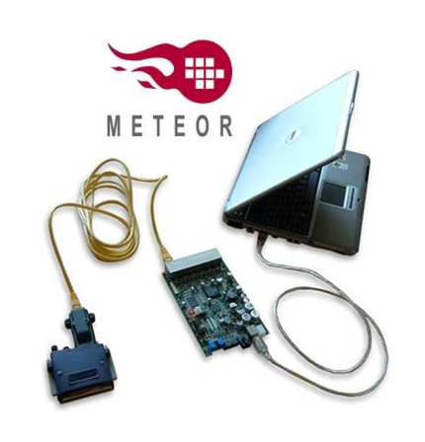

Standard USB and Ethernet cables

Windows Application

Head Driver Card

USB2 with an effective 50MB/s data rate

Printhead with up to six greyscales

Any number of Meteor cards can be daisy-chained into a single system

**Figure 2.** A simple demonstration of Meteor Architecture[4]

The software application consists of a graphic user interface, which provides complete user control over HDC configurations, offering various printing choices for different practical situations. The fast image transmission from PC to printheads allows the high printing speed, which is the basis of high productivity in printing industry.

Print Controller Card (PCC) is the control hub, which distributes image data and commands to multiple head drivers. It coordinates multiple head drivers to accomplish complicated printing jobs, for instance, printing in seamless and large scale, or printing with a high resolution, which can potentially be multiple of the printhead resolution. Figure 3 shows an example of printhead alignment to obtain larger printing scale.

Head Driver Card (HDC) is the hardware designed to achieve the best performance out of print heads. Twenty different types of printheads are supported with specialised HDCs, providing a range of choices for customer. Each type of HDC is optimised in specific ways depending on printhead choice. For instance, since different printhead follow different mechanism to fire ink droplet with piezoelectric material, they require different waveform across the piezoelectric crystal to fire ink with precise size and speed.

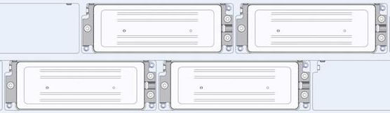

**Figure 3.** Multiple printhead alignment strategy to increase printing scale [5]

However, high flexibility and adaptability of the Meteor Architecture introduces the risk in reliability. Fast-changing environment requires Meteor to upgrade or modify our design, both in software and hardware, frequently to satisfy customer’s changeable demand. It brings the challenge that any revision or upgrade may or may not support all print head types since they are usually designed for customer with specific printhead preference. Therefore, to ensure partial modification on the Meteor Architecture does not risk the rest, a regression test procedure is essential.

Due to the limitation on time, equipment and human resource, it will be cumbersome and impractical to perform actual printing with all supported printheads in the company. This brings in the motivation of my project. By inspecting all necessary signals at hardware output, sufficient information can be collected to distinguish a ‘good’ or ‘bad’ printing behaviour. This test procedure is universal and applicable to all printheads. The Meteor Architecture will be examined on computer so this test does not require actual connection to printhead or ink system, and therefore simplify the testing procedure.

## 3.2 Project Design Procedure

The universal test project is a reasonably large project, involving multiple stages of design and implementation, from low-level hardware design to high-level user interface design. Therefore, an appropriate job organisation and time plan is essential before technical work begins.

To start with, I worked on obtaining an overview my project. Regression test is aimed to ensure changes such as upgrading do not introduce new faults. It is a general concept and there are many possible ways to realise it. The real question then becomes how to choose the optimal approach to benefit TTP Meteor most, considering deliverables, budget and time limit.

The main function of my project is to perform universal test on a range of printheads, which will mainly be used in two ways in this company:

* First of all, as is mentioned in previous section, the testing process will be included in regression test procedure, which usually happens at the end of the development cycle when deadline is approaching.
* Secondly, our customer support provides service to investigate and repair the faulty boards returned from our customer, which also helps us improving our product. Our big customer usually sends a large number of boards to repair or replacement, which is a time-consuming process. Universal test will help simplify the board review process before sending them back to customers.

Considering the most common situations universal tests will be needed, the following points should be particularly focused in test procedure design:

* Timesaving, having direct impact on efficiency of testing procedure.
* Intuitive, providing clear justification about whether test succeeds.
* Adaptive, applicable to various printheads supported by this company.

**Print Head**

**Figure 4.** Universal test on the Meteor Architecture

**User Input**

**The Meteor Architecture**

**Monitor**

**Universal Test**

Figure 4 shows how universal test operates with the Meteor Architecture. By comparing the collected output signals of the Meteor Architecture to the expected signals from user settings, test result is generated to determine whether the printing behaviour is successful. Expected signal samples are saved in PC in advance for comparison.

Following the project overview above, I started to consider the potential approaches of implementation. The implementation of the test procedure can be divided into three major parts: How to collect data from various types of printhead in order to keep the testing procedure universal? How to transfer collected data back to computer in a reliable way at a reasonable speed? How to perform reliable analysis and distinguish correct and faulty signals for different signal types? Solutions to these questions constitute the blueprint of my design, which is discussed in detail in next section. A detailed project plan was outlined after implementation approach is determined. This is discussed in section 3.3.4.

## 3.3 Technical Details

To find the optimal method to implement the universal test procedure, I familiarise myself with the hardware devices and software architecture. After comparing several different methods, I decided to use an existing type of PCC, which is an FPGA board with microcontroller and USB connection. This specific type of PCC has the name of ‘PCC-X’, which is specially designed with board-to-board connectors, providing extra possibilities on functionality. This is considered to be the optimal solution due to the low cost and large resource available to work on an existing product.

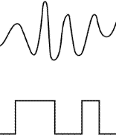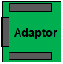

**Signal Inputs**

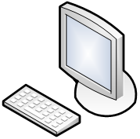

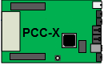

**USB 2.0**

**Microcontroller**

**FPGA**

**Figure 5.** Details of hardware components for universal test

Figure 5 illustrates the structure of the implementation chosen, using an Adaptor to access the outputs of various HDC types and sending data to PC through FPGA, microcontroller and USB. Due to the limitation on number of pins available on FPGA, it is impractical to monitor all HDC outputs simultaneously. Instead, FPGA controls the Adaptor to scan through output channels sequentially, monitoring each signal channel for one printing cycle only. A unique test image is designed to keep the data signal consistent through the printing process, which makes the data signal comparable.

Technical skills and knowledge desired for this project include PCB schematic and layout design, FPGA development using VHDL and .NET user interface design using C#. Just to give more intuition about technical work in this project, here lists the major software I used.

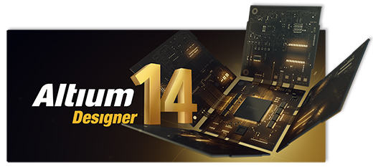

**.NET application design [8]**

**Altera FPGA design [7]**

**PCB Schematic and Layout [6]**

### 3.3.1 Adaptor board design

Before deciding how to collect signals from hardware, understanding the signal outputs of the Meteor Architecture and the working principle of printhead is essential. This session starts with explanation of the background knowledge on printhead drivers in order to understand the details of signal collection and processing.

In Meteor Architecture, HDC is at the bottom of the hierarchy, which connects printhead directly. So the outputs of HDC are what need to focus on. There are three types of signals necessary to drive a printhead, which are collected, used and analysed in different ways:

* Analogue waveforms, which vary for different printheads
* Digital signals, including clock, latch and data, which vary for different images
* DC power supplies, which vary for different printheads

Figure 6 shows printing mechanism from the perspective of printhead driver signals. This mechanism is similar for all printheads using piezo technology. At the beginning of a printing cycle, serial image data are clocked into printhead by latch signal, followed by an analogue waveform which drives the piezo crystal to fire ink drop.

**Figure 4.** Data sequencing diagram

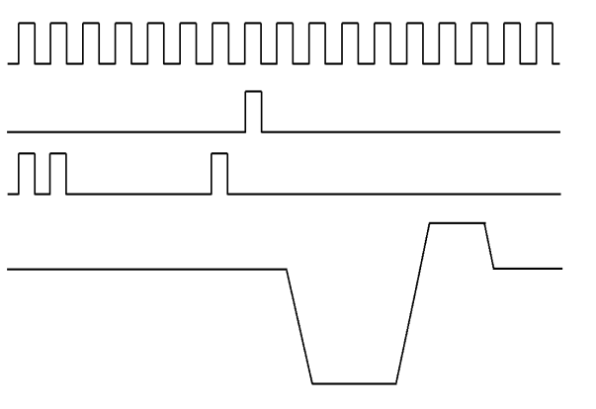

**1 Print Cycle**

**Clock**

**Data**

**Waveform**

**Latch**

**Figure 6.** Driving signals for printhead using Piezo technology

As is shown in figure 7, piezoelectric inkjet is based on the phenomenon of piezoelectricity where the physical shape of piezoelectric material bends and vibrates with the voltage applied. When the voltage is reversed, crystal rapidly bends to the opposite direction, firing ink drop at a high speed. With careful design of waveform, ink drop size can be controlled in micrometre, allowing high printing resolution and precision.

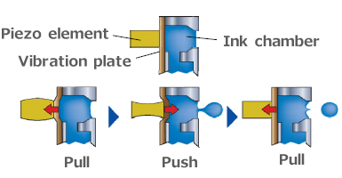

**Figure 7.** Piezo technology to jet ink drop [9]

In my project, the latch signal is used to trigger and synchronise the collection process for each printing cycles. There are 32 analogue channels and 32 digital channels available, providing sufficient capacity to monitor a range of HDCs. Signals are sampled at 20 Msps to avoid aliasing. Analogue waveforms are passed through a noise-removal filter and an analogue-digital converter before being collected by FPGA.

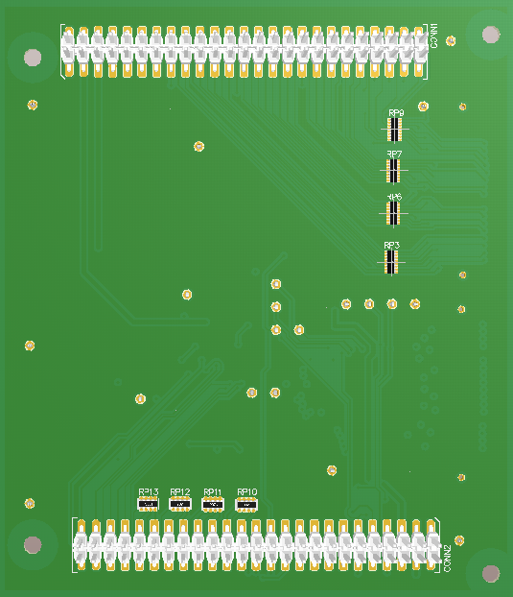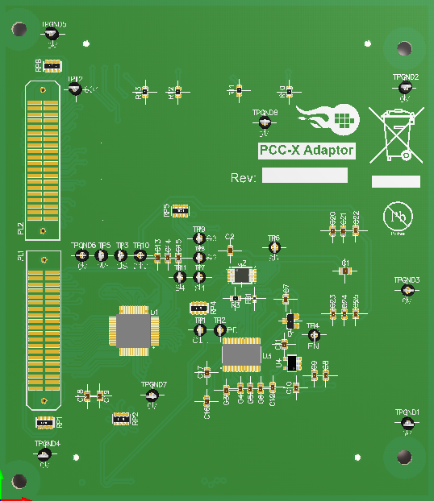

**Figure 8.** 3D layout model of PCC-X Adaptor

Figure 8 shows the 3D mode of the adaptor board. Though the functionality of the adaptor board is not complicated, ensuring its safety and reliability does require extra circuit design techniques.

Many circuit protection techniques are applied to minimise the risk when high-voltage faulty signals present. Protection diodes and resistors are placed to prevent FPGA from damage by maintaining external signals under the safety voltage. Ground wires are inserted between high frequency signals to minimise the crosstalk. Path of the clock signal is designed not to cross any other signal to minimise the effect of noise. Control signals of the multiplexer and the ADC are designed to have similar length to minimise skew.

Compared to complexity of other PCB design in this company, the Adaptor board I designed is trivial. However, it turns out to be the most cumbersome part in this project, owing to manufacture standards and conventions which ensure the board meet the requirements to be manufactured. The requirements are specific and cover all the details such as hole-to-hole clearance, minimum annular ring size, polygon clearance, etc. Engineers in this company sometimes need to adjust these standards based on their experience to reduce the risk of manufacture failure.

### 3.3.2 FPGA design

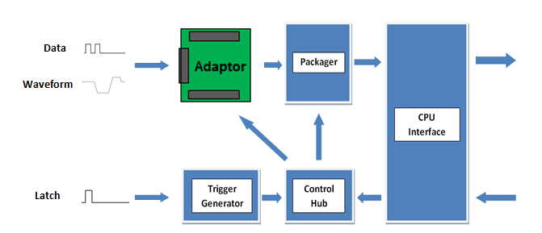FPGA acts as an intermediary between software layer and hardware layer. It reads the commands from software, controls the operation of adaptor board, collects and delivers data packets back to software. How to execute the universal test is defined in this part.

**User commands**

**Data to Software**

**Figure 9.** Intuitive block diagram of my FPGA design

**Digital Data**

Figure 9 illustrates the operation mechanism of FPGA blocks with the adaptor board. Latch signal is used to trigger the test. Samples taken from each channel are labelled, packaged and sent through microcontroller interface to PC. During the FGPA development, I found the content learned in college VHDL course and digital electronics particularly useful. For example, the long propagation delay between FPGA and microcontroller interface makes the command signals difficult to meet timing requirement at system clock frequency. This problem is eventually resolved by moving the FPGA output blocks to a slower time domain and introducing pipelining.

Implementing the FPGA components is a practical and demanding job. As the designer, I not only need to determine the details about the testing steps and packaging methods, but also desire to assemble the individual blocks and functionalities together into a compact system. The work involved in debugging the interfaces is usually multiples of the work of implementing individual functionalities.

### 3.3.3 User Interface Development

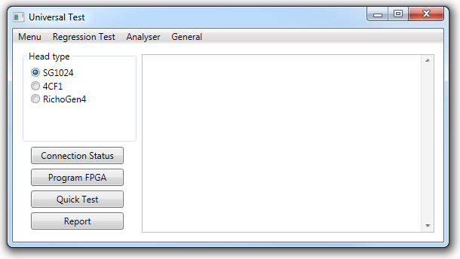A WPF application based on .Net framework has been developed to monitor the universal testing process, aiming to provide reliable and informative data analysis while reducing the operation required from user. Figure 10 shows the main interface with the intuitions of test procedure and function categories.

**Figure 10.** Main window of universal test application

The user interface design involves three main functional areas: data entry, sequence control and data display [10].

First of all, the application customises the test process by accessing user configurations such as printhead type, print rate, and signal declarations. Parameter settings and user input are saved in command registers on FPGA. Labelled samples are sent through microcontroller fast data bus running at 80Msps, raw data in byte code are converted into readable format for further analysis in software.

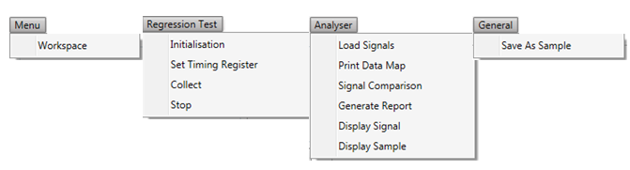Secondly, the application covers the entire testing process, where the individual steps are highly dependent on each other. User might obtain corrupted data or overload CPU by creating redundant threads if unexpected operations are performed. Accordingly, a series of conditional variables are used to indicate the state of test process, which maintain the procedure under control and reduces the risks of introducing bug by user operation. Error messages are provided to guide user to follow the correct test steps.

**Figure 11.** Drop-down menu bars

By providing detailed and low-level functions under drop-down menus such as FPGA command register control, shows as Figure 11, this application provides developers with sufficient freedom over the testing process. In the other side, individual functions are combined into a ‘Quick Test’ function, which minimise the user input required for convenience.

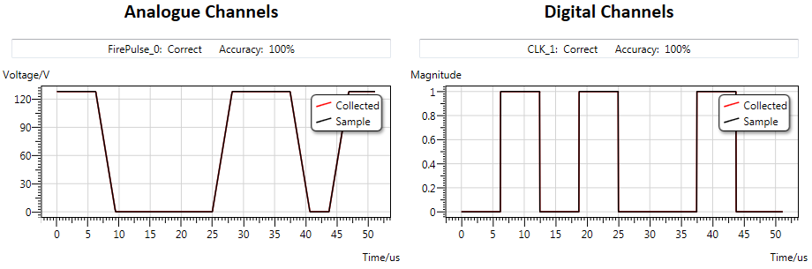

**Figure 12.** Graphic display of analogue and digital signals

Thirdly, an external library named ‘Dynamic Data Display’ is used to provide user-friendly interface to present data because C# is not particularly dedicated in graphics, shown in Figure 12. Any obvious deviation from the sample data can be observed from the graph, while the accuracy estimates the similarity between signals, by calculating the cross-correlation between collected data and pre-saved data, which is useful since noise in amplitude and time axis always exists.

Considering their corresponding characteristics, different signal types are analysed and compared to the saved samples in different ways.

First of all, waveforms are used to charge piezoelectric materials and use the resulted shape change to fire ink droplet. Therefore, waveforms have certain tolerance in its shape. In practice, two criterions are used to justify whether a waveform meets our requirements:

* Boundary voltage levels, which determines the material shape before and after ink droplet is fired.
* Slew rate, the derivative of waveform varying, which controls the jetting movement of the crystal.

Considering the noise introduced in hardware and the limited bandwidth of ADC, reasonable amount of deviation in slew rate and should be tolerated. Figure 13 shows an example of evaluating waveform with 1% tolerance in voltage boundaries and 10% tolerance in slew rate.

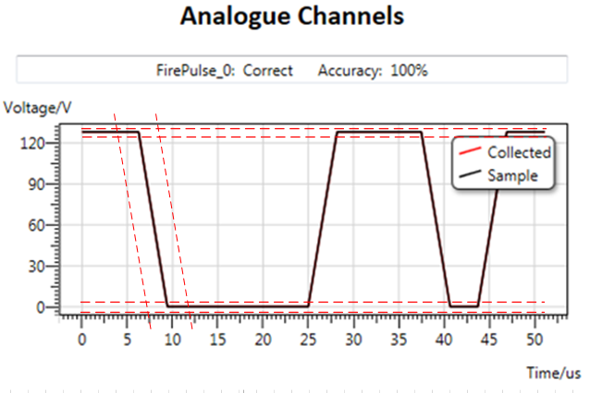

**Figure 13.** Example of waveform evaluation

Regarding digital signals, which consist of 1s and 0s only, any faulty value is obtained at clock edge will cause the signal to be categorized as faulty. Digital signals that are sampled at high system frequency are then downsampled to the frequency of printhead data clock, giving more tolerance to noise and signal skew. Also, it is a reasonable method to justify digital signal only by the actual digits that received by its target, in this case, printhead.

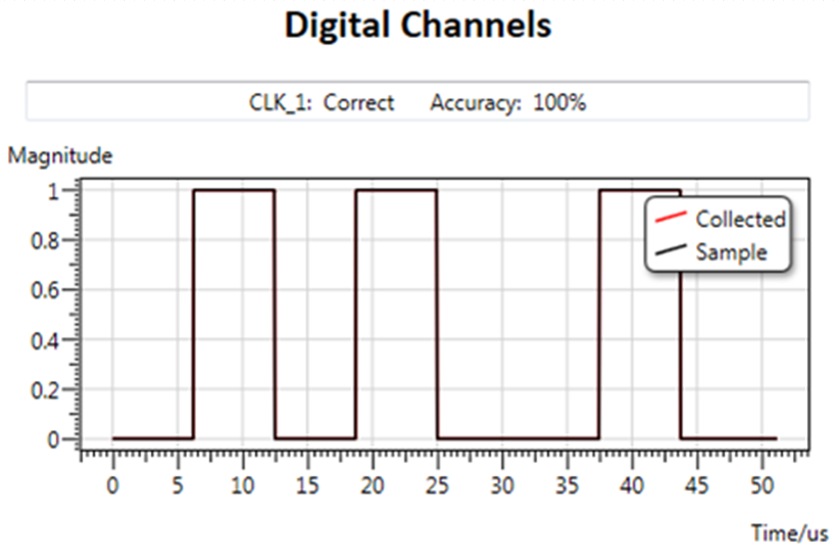

**0**

**0**

**1**

**1**

**Samples to inspect**

**Figure 14.** Example of digital signal evaluation

User interface design is a time-consuming but entertaining process. Starting from implementing basic functions to interface with hardware, to finalise analysis and present graphic results to user, the application have to accomplish a large amount of work in the background which is hidden from user and only present the most concise content to user. Implementing bug-free functions is the most basics in this application. Based on it, low-level functions are abstracted and combined into meaningful functions which are presented to user and guide user through the testing procedure.

Another point which some programmer might downplay is user experience. In my application, many function such as programming FPGA and data collection do not finishes instantly. Separate threads are created to prevent application from stall. Efficiency is also improved by running different analysis parallel to each other.

### 3.3.4 Project Planning

After investigating possible approaches to implement the testing system and estimating the amount of work involved, a detailed project plan is drafted to manage time and instruct design procedure. Please see Figure 15.

**Figure 15.** Project timeline plan

The time plan has included extra time at the end of each designing stage to compromise the time consumed for unexpected events. Despite the consideration of contingency, the actual development process did not follow the plan. This is caused by a customer order of our new product, which is due this October. The PCB design of the driver board and testboard for the new product with a higher priority occupies most resource in company, resulting in the suspension of my adaptor board design.

Meanwhile, to make the best use of my working time, I started FPGA and Software development in advance of the planned date, which allows extra time before the end of the placement to examine the cooperation between my PCB, FPGA and software application.

## 3.4 Additional Work

Apart from the Universal Test project, I was also often allocated other tasks to gain insight into other job, such as testboard design and customer support.

I participated in the testboard schematic design for the two types of printhead driver cards, which detect the manufacture error through examining supply voltages and image data. On the other side, I had opportunities to attend conference call, providing technical support to our clients who are Mandarin speakers. It is a pleasant process to help our engineers communicating with clients and improve the efficiency of conversation.

# 4. Project Refection

The varieties of work I attempted in TTP Meteor broaden my view of jobs in engineering industry, making me aware of my interest and abilities. During this placement, I have experienced working in a technical consulting industry, where challenges happen every day. Compare to the student project or college lab experiments, which focus more on ideas and innovations , my placement project contains more practical implementation since it will be finally used inside the company as part of the regression test process.

In general, this placement has taught me much more than technical skills, I learnt knowledge and skills not only as an engineer, but more importantly, as a person. Many problems and challenges I encountered were not foreseen before the placement began. Owing to this, fortunately, I learned much more than I expected.

## 4.1 Challenges

The universal test project is a long and complicated project involving multiple stages of design and implementation, requiring careful organization and plan in both time and content. Taking the responsibility of developing the project, I faced many challenges other than the technical difficulties.

In the early stage of the placement, when implementation details remained undetermined, there are many possible and feasible ways to perform this project and probably most of them would succeed. Cautious and intellectual decision-making, which potentially leads to the best deliverables, requires a good overview, considering the complexity of technical jobs involved, limited time and resource during this placement and the actual objectives of the projects.

Since my project is specialised for the development procedure in TTP Meteor, understanding the aim and intuition of this project requires me to be aware of the technical and business aspects of the company, before determining any details about project design. To obtain a clear understanding about my project, I started with learning more about the products and development process in this company in the first several weeks of my placement. This helps me recognizing the real demand behind my project and the functionalities as well as characteristics that require focusing on to solve the problem.

In real industry, most problems encountered are practical. Delay in hardware manufacture, accidental damage to experimental hardware, limited resource shared by a group of engineers, variables like this can never be predicted and always leads to the change of the original project plan. Sufficient time and possible alternative approaches should be planned in the original project plan before any actual development begins. Though in this placement I have planned additional time for contingency, the progress of my project still struggles to meet the deadline.

## 4.2 Personal and Professional lessons

My responsibility of this project requires me consider and coordinate all aspects involved during development, from code writing to arrange component purchasing, from technical details to project management. All the challenges, technical or non-technical, have helped me to recognise my weakness and advantages, and inspired me to reconsider myself in terms of my career path and skill set.

Working as a novice in a company, technical skills may not considered being the most important, since most people around have more experience in technical development and deeper understanding in company business. Accordingly, how to communicate with others and make the best use of the resource in the company has enormous impact on productivity and working efficiency.

Assuming the individual learning curve does not improve dramatically in short term, the assistance from surrounding people then largely determines the final result. During this placement, I realised that the work I spent weeks on might only cost a few days for an experienced engineer. It encourages me to communicate more with my colleagues and listen to their suggestions and advice.

Furthermore, most large companies tend to have their own regulations and conventions in development process to maintain the work format inside company consistent. In the first few weeks of the placement, I designed the PCB schematics and layouts from scratch, which does not match the design rules in company and failed the review from my colleagues, which cost significant amount of time to revise and modify. Being aware of what approaches to carry out the project in advance will save significant amount of time and work. Again, this problem can be prevented by discussing with the professionals.

## 4.3 Future work

Since my project is part of the regression test system, it will be inherited and improved by others. Detailed documentation in both windows application and FPGA code are written, explaining the working principles of the software. During the code development, the variables I used are given meaningful names, reducing the difficulties in comprehension for future developers. Input parameters and returned results are all well-documented in software. Project reports and documents explaining the overview and design ideas of this project will be kept.

## 4.4 Relevance to degree course

This placement is closely related to college content, including Digital and Analogue Electronics, Power Engineering, VHDL and Logic Synthesis and programming labs. Benefiting these courses, especially VHDL and other programming courses, I was able to accomplish the VHDL and software design of my project within less time than I expected.

I appreciated this opportunity to take this placement project, which covers a range of areas including PCB design, VHDL development and high-level user interface design. I was provided with an opportunity to explore my interest and perceive the particular area of engineering that fascinating me. So far, I feel most comfortable in high-level software development, in my project, the .NET user interface design. It directly interacts with user and has immediate influence on user experience. This encourages me to learn more about high-level software design in the future.

# 5. Conclusion

To summarise, during placement, I took the responsibility of the universal test project, which is a more efficient way to examine the outputs of a variety of targeted hardware. This project will be finally used to include the hardware components into the company regression test. Apart from learning technical skills in software and electronics design, I improved my ability of managing and organising sophisticated projects, gaining experience in working and communicating with people in different areas. Despite of the challenges and difficulties encountered during this placement, I received enormous help from people around me and I was pushed through the challenges.

After gaining insight into the electronics industry, I developed my understanding in different roles in an electronics company. Through attempting various types of job, I improved my self-awareness of my advantages and weakness, realising skills that I should focus to improve. This placement has provided me with many feedbacks, which are essential guidance and suggestions I will carefully consider and follow in my future career.

Finally, I appreciate this opportunity to work in TTP Meteor, with many experienced and talented engineers. With six months of pain and gain, this placement has become the experience I will always remember.

# Reference

[1] History of TTP Group. <http://www.ttpgroup.com/#history>

[2] Image source: <http://www.ttpgroup.com/uploads/default/files/ttp-exterior-wide1.jpg>

[3] Regression test, <https://en.wikipedia.org/wiki/Regression_testing>

[4] Internal source: Meteor3.ppt, Page 3. *“The Technology Partnership PLC, A Science and Engineering Services Provider, delivers the Meteor Print Controller”*

[5] Internal source: PM000065, StarFire SG-1024-C Printheads Product Manual, Page 24 *Figure 2-8 Bottom view, multiple printhead alignment*

[6] Image source: Altium Designer Logo <https://pp.vk.me/c616624/v616624384/d5c0/M6WgKncmbfA.jpg>

[7] Image source: Quartus II logo <http://www.f07.fh-koeln.de/imperia/md/content/personen/krah_jens/ppt_mh.pdf>

[8] Image source: Visual Studio Logo <http://i1.wp.com/ingenieriaelectronica.org/wp-content/uploads/VIsual-Studio.png>

[9] Image source: <https://szwilk.files.wordpress.com/2014/09/tech_atrament.pdf>

[10] GUIDELINES FOR DESIGNING USER INTERFACE SOFTWARE <http://hcibib.org/sam/>